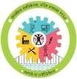 

# GOVERNMENT POLYTECHNIC, NANDED

**MICRO PROJECT**

## Academic year: 2020-21

**TITLE OF THE PROJECT**

**Blood Donor Receiver App**

**Program:** Information Tech. **Program code:** IF6I

**Course:** CPE(Capstone Project Execution) **Course code:** 22060

**Name of Guide :- Mr.M.M.Shaikh**



# MAHARASHTRA STATE BOARD OF TECHNICAL EDUCATION

**Certificate**

### This is to certify that Roll No. **1547, 1570** of **6th** Semester of Diploma in **Information Technology** of Institute, GOVERNMENT POLYTECHNIC has completed the **Micro Project satisfactorily** in Subject - CPE **(22060)** for the academic year 2020 – 2021 as prescribed in the curriculum.

Place: **Nanded**

Date:

**Subject Teacher Head of the Department Principal**

**Mr.M.M.Shaikh**  **Mr. S. N. Dhole Sir** **Dr. G.V. Garje**

**CERTIFICATE**

This is to certify that Mr./Ms. 1547, 1570 from GOVERNMENT POLYTECHNIC NANDED Institute having Enrolment No. 1) 1800200113 2) 1800200119 has completed Project of final year having title “Blood Donor Receiver App” during the Academic year 2020- 2021. The project completed by individually / group consisting of persons 1) Shivhar Ram Bane 2) Harsh Santosh Zanwar under the guidance of the faculty guide.

. ……………………………..

………………………………

Name and Signature of Guide: - Mr M.M. Shaikh

Telephone……………………

**ACKNOWLEDGEMENT**

On the occasion of presenting this project report, we wish to express our deep and profound feelings of gratitude to a number of persons who have contributed to the completion of this project.

First of all we express our deep gratitude to **Almighty**, the supreme guide, for bestowing his blessings upon us in our entire endeavor.

We are grateful to our respected Principal **Dr. G.V.GARJE Sir** for providing all facilities for the development of our project.

We also express our heartfelt gratitude to **Mr.S.N.DHOLE Sir** our Head of the Department for rendering all possible help and support during the development, implementation and presentation of the project.

We are extremely grateful to **Mr.M.M.Shaikha Sir** lecturer-in-charge of our project for his valuable guidance and encouragement throughout our humble endeavor.

**WEEKLY PROGRESS REPORT**

**TITLE OF THE MICRO PROJECT:- Blood Donor Receiver App**

|  |  |  |  |
| --- | --- | --- | --- |
| **W E E K** | **A C T I V I T Y P E R F O R M E D** | **S I G N O F G U I D E** | **DATE** |
| **1ST** | **Discussion and finalization of Topic** |  |  |
| **2ND** | **Discussion and finalization of Topic** |  |  |
| **3RD** | **Preparation and submission of Abstract** |  |  |
| **4TH** | **Literature Review** |  |  |
| **5TH** | **Collection of Data** |  |  |
| **6TH** | **Collection of Data** |  |  |
| **7TH** | **Collection of Data** |  |  |
| **8TH** | **Collection of Data** |  |  |
| **9TH** | **Discussion and Outline of Content** |  |  |
| **10TH** | **Formulation of Content** |  |  |
| **11TH** | **Editing and 1st Proof Reading of Content** |  |  |
| **12TH** | **Editing and 2nd Proof Reading of Content** |  |  |
| **13TH** | **Compilation of Report and Presentation** |  |  |
| **14TH** | **Seminar** |  |  |
| **15TH** | **Viva-voce** |  |  |
| **16TH** | **Final submission of Micro project** |  |  |

Sign of the student Sign of the faculty

Mr. M.M.Shaikh

**ANEEXURE II**

**Evaluation Sheet for the Micro Project**

|  |  |  |
| --- | --- | --- |
| **Academic Year:** 2020-21 |  | **Name of the Faculty:** Mr.M.M.Shaikh |
| **Course:** CPE | **Course code:** 22060 | **Semester:** VI |
| **Title of the project:** Blood Donor Receiver App |  |  |

**Cos addressed by Micro Project:**

**A: Interpret Value Added Services**

**B. Study on MVAS**

**Major learning outcomes achieved by students by doing the project**

* + - 1. **Practical outcome:**
         1. Deliver report effectively.
      2. **Unit outcomes in Cognitive domain:**
         1. Prepare the points for computer presentation.
         2. Make seminar presentation.
      3. **Outcomes in Affective domain:**
         1. Function as team member.
         2. Follow Ethics.
         3. Make proper use of computer and Internet

**Comments/suggestions about team work /leadership/inter-personal communication (if any)**

|  |  |  |  |  |
| --- | --- | --- | --- | --- |
| **Roll No.** | **Student Name** | **Marks out of 4 for performance in group activity ( D 5 C o l . 8 )** | **Marks out of 2for performance in oral/ presentation ( D 5 C o l . 9 )** | **Total out of 06** |
| 1547 | Shivhar Bane |  |  |  |
| 1570 | Harsh Zanwar |  |  |  |

**(Signature of Faculty) Mr.**M.M.Shaikh

**ABSTRACT**

The combination of the smart phone and the Internet service is the trend of the future information development and software applications. Mobile phones are the most commonly used communication tools. Using mobile phones to obtain information is not only quick, but also more convenient shortcut to improve people's lives. In the paper, we propose the software development architecture based on Web services. This framework introduces the three-layer architecture of Web development into mobile phone software development. Based on the three-layer architecture, the android based Blood Donor Receiver App

is developed. The android based Blood Donor Receiver App can realize to query information for Blood Donors , Blood Notifications . The android based city guide system has more practical significance. In the current scenario there isn’t any application that would help to a Blood Receiver to get information about the Blood Donor they are currently visiting in their mobile phone.

**INDEX**

|  |  |  |
| --- | --- | --- |
| **Sr.No.** | **Name** | **Page No.** |
| **1** | Introduction | 1 |
| **2** | Literature Review | 2-3 |
| **3** | Scope of Project | 4 |
| **4** | Design (Screenshots) | 5-13 |
| **5** | Results And Application | 14 |
| **6** | Future Scope | 15 |
| **7** | Conclusion | 16 |
| **8** | References | 17 |

**Introduction**

The **Android operating system** is the largest installed base among various mobile platforms across the globe. Hundreds of millions of mobile devices are powered by **Android** in more than 190 countries of the world. It conquered around **75%**of the global market share by the end of 2020, and this trend is growing bigger every other day.

To develop apps using the SDK, we use the [Java programming language](https://en.wikipedia.org/wiki/Java_(programming_language)) to develop the app and [Extensible Markup Language](https://en.wikipedia.org/wiki/XML) (XML) files to describe data resources. By writing the code in Java and creating a single app binary, you create an app that can run on both phone and tablet form factors. You can declare your UI in lightweight sets of XML resources.

We have created this app by looking at someone’s situation. This application is to help people who are suffering with their health and needy for blood.

Literature Review

BACKGROUND TECHNOLOGIES:

Android :

Developers create apps for a variety of reasons. They may need to address business requirements or build new services or businesses, or they may want to offer games and other types of content for users. Developers choose to develop for Android in order to reach the majority of mobile device users.

JAVA :

## Why Use Java?

* Java works on different platforms (Windows, Mac, Linux, Raspberry Pi, etc.)
* It is one of the most popular programming language in the world
* It is easy to learn and simple to use
* It is open-source and free
* It is secure, fast and powerful
* It has a huge community support (tens of millions of developers)
* Java is an object oriented language which gives a clear structure to programs and allows code to be reused, lowering development costs

Problem statement for this Android App :

I have created this app by looking at this situation todays situation blood donor can not give blood because lockdown situation. In this Covid-19 situation People Could't Donate their blood at Blood Centers .They have no willing to take risk in such situations and Donate Blood But The problem is the Demand if Blood Transfusion has Increased. Which Cause a lot of Shortage at Blood Camps.

This makes it impossible for the middle and poor to have a blood supply And in such a situation, the signs of death are increasing. And in that case, you don't even get the blood donors of the blood group you need.

Problem Solving :

The concept behind this application is to meet blood donor and blood receiver without any third person . The donor can directly donate the blood to the needy patient.

This way we can fulfill need of the patient and satisfaction

for blood donor.

This platform we help those who are willing to donate The blood and save someone life.

Scope of Project

This application is to help people who are suffering with their health and needy for blood. Some time the situation of a person who is looking for blood is so critical that he or any of his family member face difficulty to find blood or blood donor. The concept behind this application is to meet blood donor and blood receiver without any third person . The donor can directly donate the blood to the needy patient. This way we can fulfill need of the patient and satisfaction for blood donor.

This platform we help those who are willing to donate The blood and save someone life.

**Design (Screenshots)**

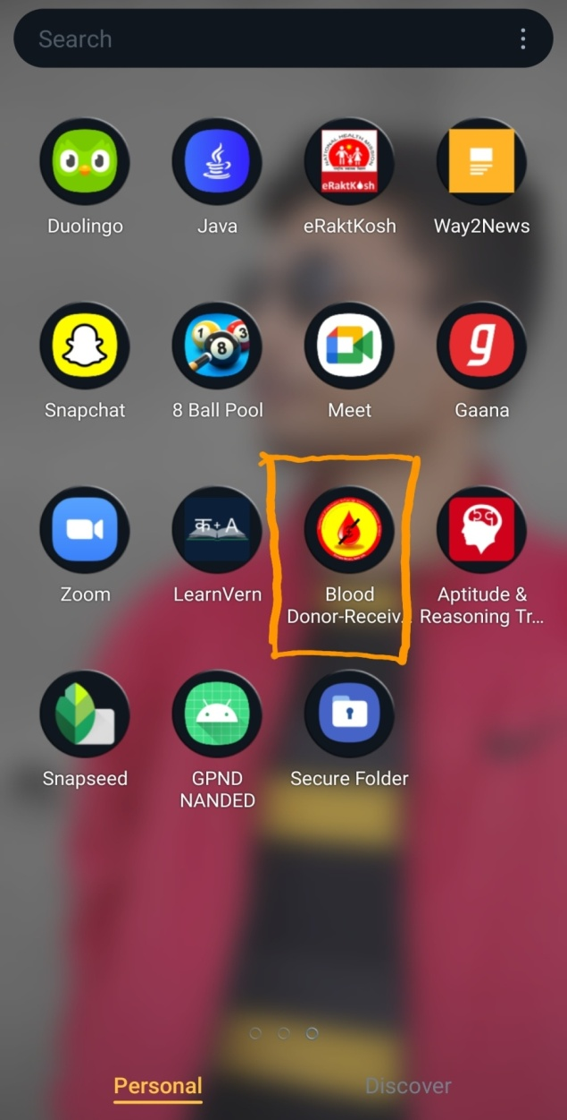 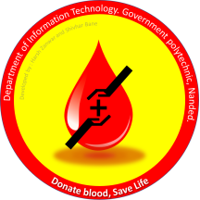

**Icon**

**Design :**

Home Page and Menu Page :

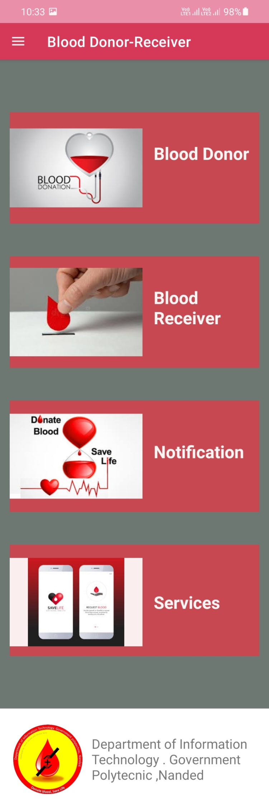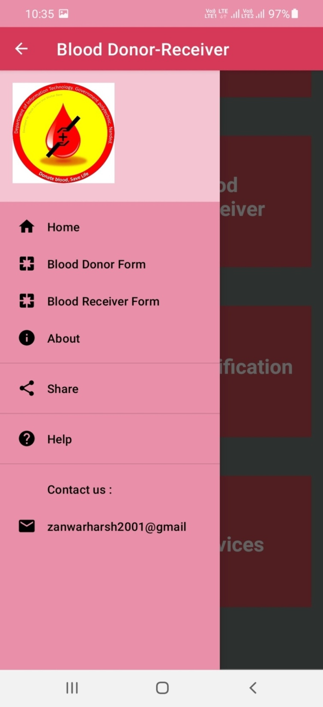

Donor Form Page :

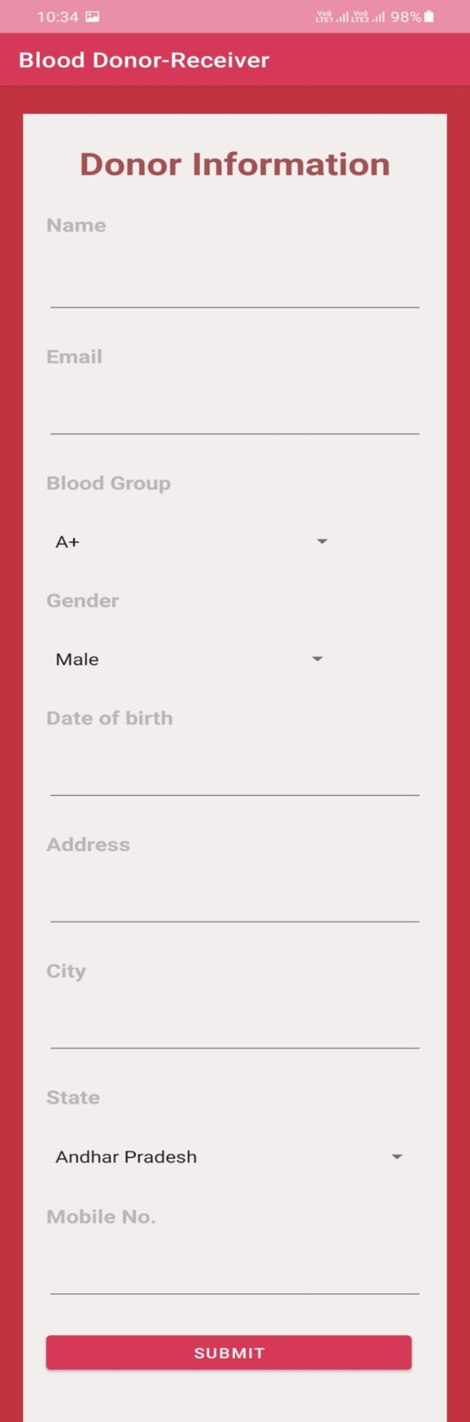

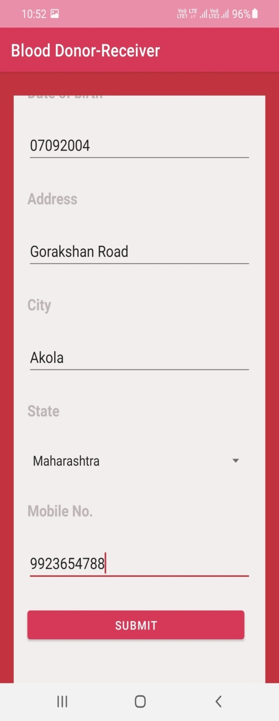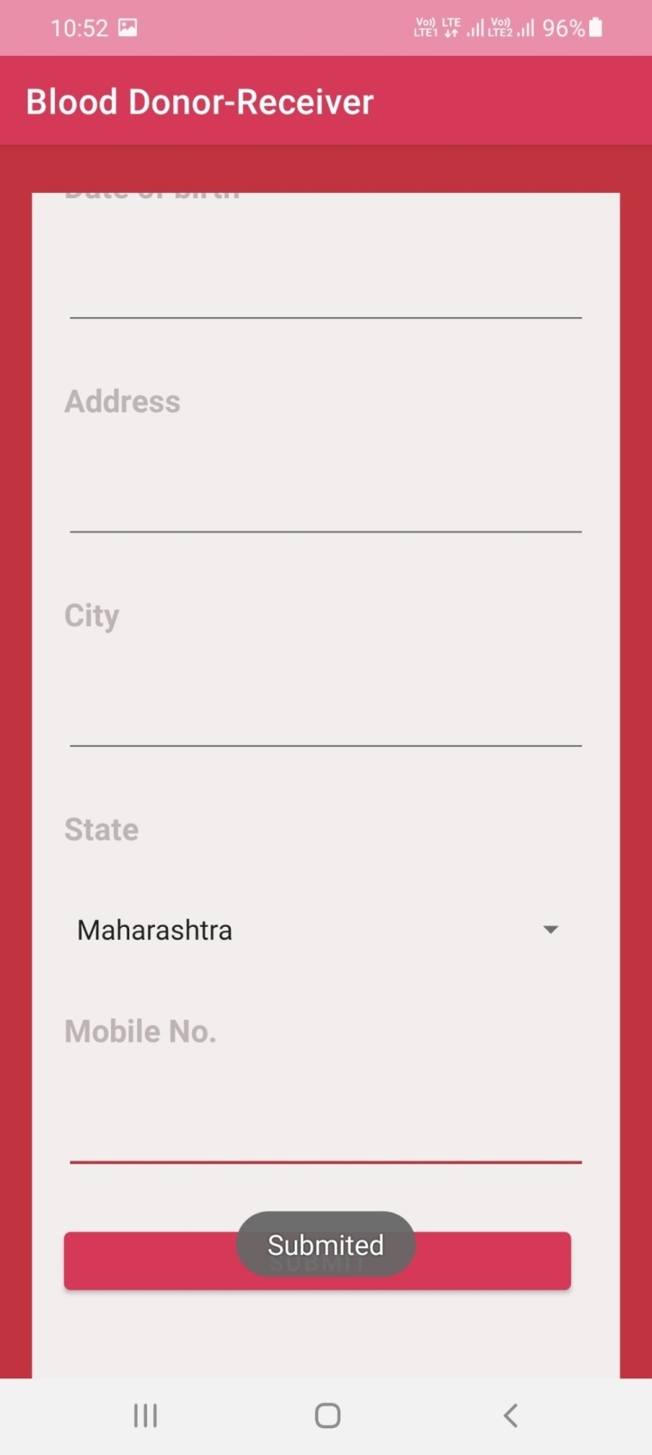

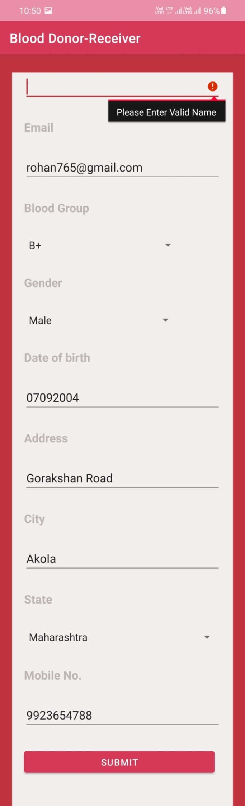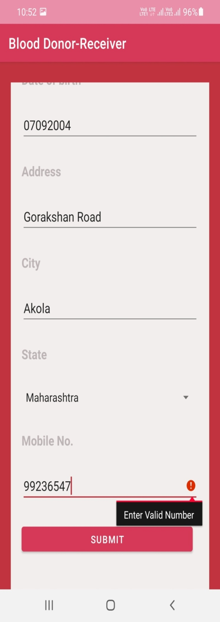

Blood Receiver (List Blood Donor) :

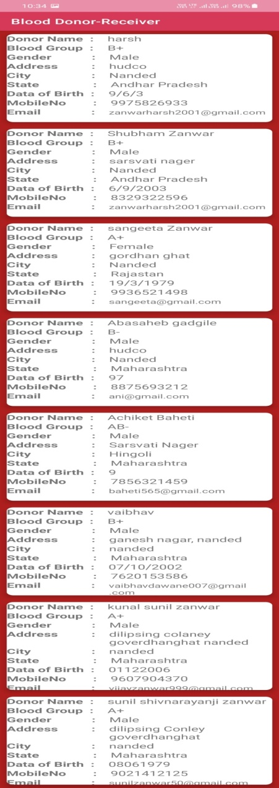

Notification And Service Page:

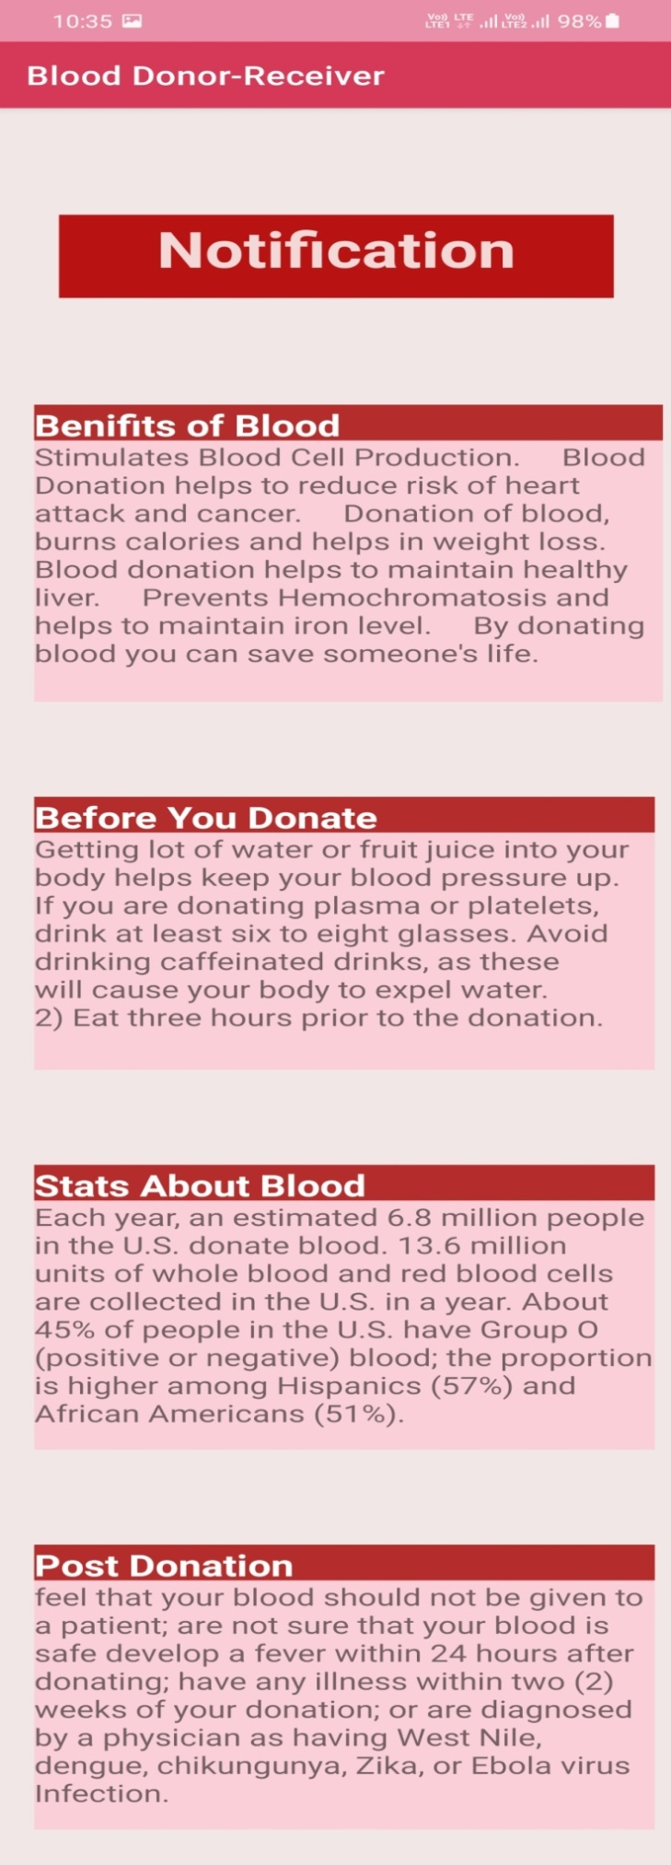 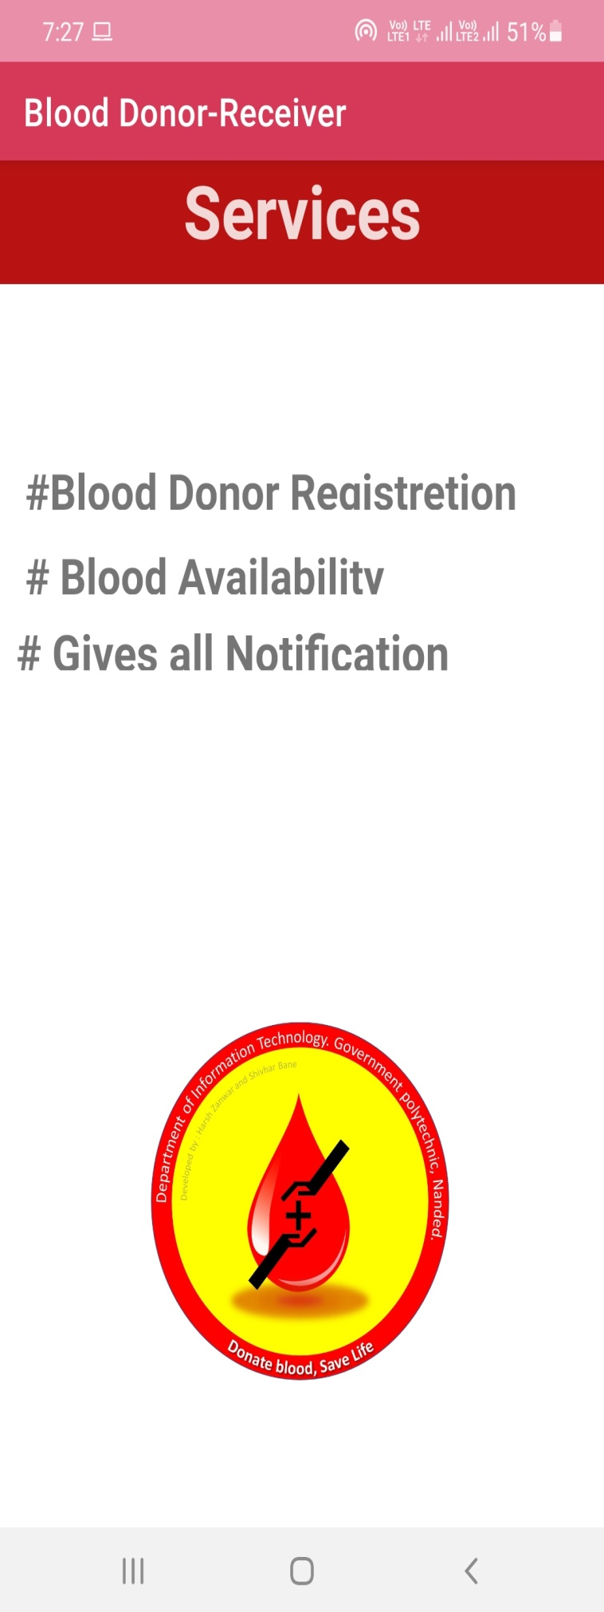

About :

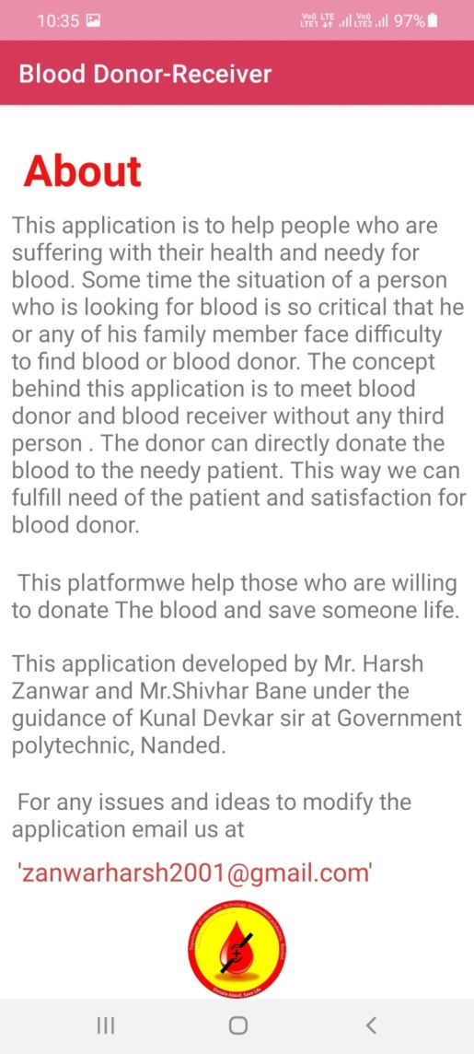

FIREBASE :

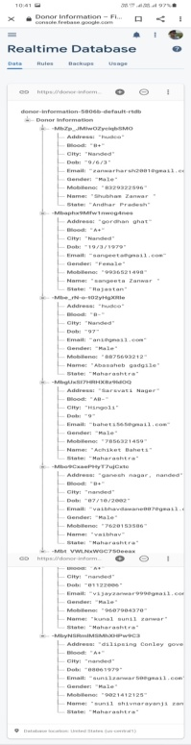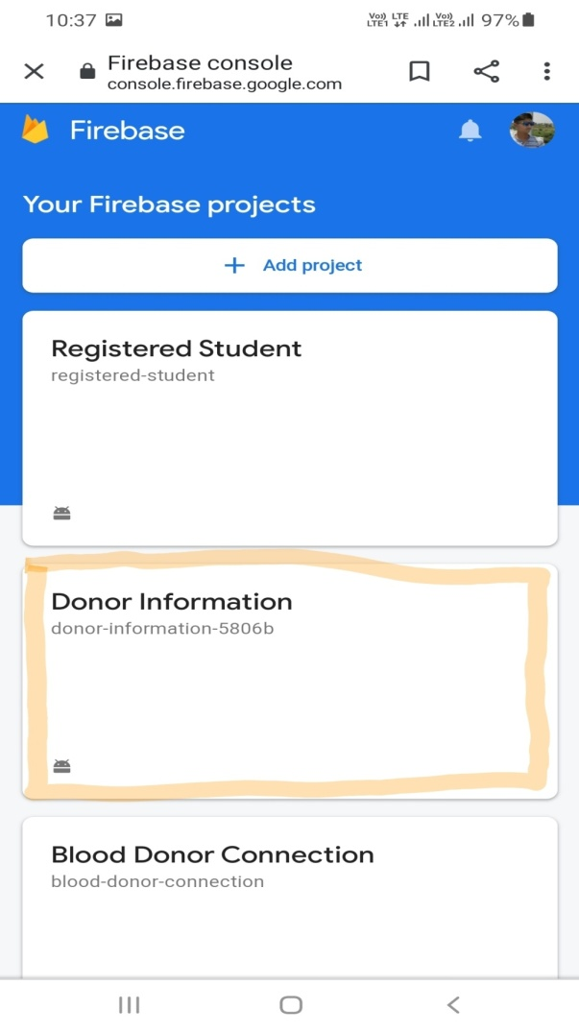

**Results And Application**

The Importance Of Mobile Applications In Everyday Life!

Ex. Apps for entertainment

Apps for communication

Apps for Education..etc

You will find the android applications  at the top layer and you will write your application and install on this layer. Example of such applications are contacts, books, browsers, services etc. Each application perform a different role in the over all applications.

In the same way we have also created an app his name is Blood Donor Receiver App. Anyone who wants to donate blood can put their own information in it and anyone who wants blood can do so through this app can see blood donor information.

**Future Scope**

With this app, we will distribute special prizes to those who have donated blood. We will organize various events. Suppose a person wants blood, he can get it easily by filling in the information with the help of that app. If he wants blood, we will go ahead and offer it. The blood supply service can be faster than other blood banks so that a person can get blood in time. This app will be available to people easily by changing it day by day.

**Conclusion**

We have learned through this project that the mobile application development is rapidly growing and interesting field and we have chances to make carrier in this field. Within preparing this app we learned many concepts of app development but its just a little knowledge about it. Mobile application development have wide scope in whole world.

Mobile applications are easy to maintain than any software for any type of information. We can easily access it. This is emerging technology.

**References**

* **Book References:**

# 1. Android Programming for Beginners

2.Complete reference of Android

* **Web References:**
* http://www.google.com
* http://www.tutorialspoint.com
* http://www.tutorialspoint.com/android
* httphttp://WWW.javatpoint.com



## MAHARASHTRA STATE

## BOARD OF TECHNICAL EDUCATION

**Certificate**

This is to certify that Mr **Shivhar Bane** Roll No.**1547** of 6thSemester of Diploma in Information Technologyof Institute, GOVERNMENT POLYTECHNIC has completed the **Micro Project satisfactorily** in Subject – CPE (22060)for the academic year 2020- 2021as prescribed in the curriculum.

Place: **Nanded**

Date:

### **Subject Teacher Head of the Department Principal**

**Mr.M.M.SHAIKH Mr.S.N DHOLE DR. G.V. GARJE**



## MAHARASHTRA STATE

## BOARD OF TECHNICAL EDUCATION

**Certificate**

This is to certify that Mr.**Harsh Zanwar** Roll No. **1570**of 6thSemester of Diploma in Information Technologyof Institute, GOVERNMENT POLYTECHNIC has completed the **Micro Project satisfactorily** in Subject – CPE (22060)for the academic year 2020- 2021as prescribed in the curriculum.

Place**: Nanded**

Date:

### **Subject Teacher Head of the Department Principal**

**Mr.M.M.SHAIKH Mr.S.N DHOLE DR. G.V. GARJE**